Computer-assisted drug discovery – startup challenge

Group 4

Nola Lior | N.k.lior@student.tue.nl
Sep  Meulders | s.a.meulders@student.tue.nl
Derek Kentie | d.b.s.kentie@student.tue.nl

Introduction
The vast majority of existing processes of discovering new medicines struggle to achieve accurate predictions due to their slow, expensive, and uncertain nature. This happens because of few training samples, non-informative feature representations, and misbehaving models (e.g., overfitting or underfitting). These gaps may lead to inaccurate decisions and loss of important information about chemical matter. Predictive approaches that use computational tools to analyze chemical data and predict which molecules may be biologically active have been an effective solution (computer-assisted drug discovery (CADD)).

The goal of this project is to come up with a method that will enable us to make more accurate predictions. Hence, we should propose a technique that is more accurate and can effectively handle the available data. This includes determining whether small molecules can bind to a protein target that is involved in a particular disease. Given the complexity of the underlying data, the challenge lies in extracting meaningful information from chemoinformatic datasets and developing a model that accurately predicts the bioactivity of untested molecules.

When organizations address this problem, they will have the advantage of making better decisions and discovering new uses. When a model works properly, it saves time, minimizes mistakes, and accelerates the discovery of drug candidates.

Materials and methods
Molecular descriptor calculation.
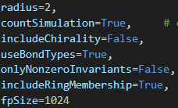
The molecules were represented using both RDkit.chem descriptors and RDkit.chem Morgan fingerprints. The Morgan fingerprints are used to depict molecules based on neighboring atoms and the way in which these atoms interact with each other, based on, for instance, bond types. The radius indicates the maximum number of atoms that the MorganGenerator will consider in the current molecule with respect to the current atom. The RDKit descriptors characterize the physicochemical and structural properties of molecules. The selection of these descriptors has been refined by excluding those with missing values, those exhibiting a standard deviation lower than 0,001 and those with a correlation exceeding 0,9. This process has reduced the total number of descriptors from 217 to 94. In contrast, the Morgan fingerprints were refined exclusively by eliminating constant values, as their data is binary in nature. Additionally, we finetuned several hyperparameters, as illustrated in Figure 1. These adjustments were strategically selected to achieve an optimal balance between chemical expressiveness and computational efficiency. The resulting representations are categorized into three types: descriptor representation, fingerprint representation, and computational efficiency.
Figure 1: hyperparameters applied on GetMorganGenerator to calculate fingerprints

Protein representation.
In this analysis, we have chosen to utilize three distinct methods for the representation of amino acids: one-hot encoding, physicochemical property encoding, and substitution matrix embeddings (PAM62 and BLOSUM250). Each of these methods produces 1-dimensional arrays that characterize the amino acids. Additionally, combined representations are employed, specifically concatenating physicochemical properties with substitution matrix data. These methods facilitate the representation of proteins as 1-dimensional arrays through two primary approaches: either by encoding each amino acid as an individual array and subsequently concatenating them, or by partitioning the protein into several segments, computing the average for each feature, and then concatenating these averages. The latter approach is utilized when uniform array lengths are required. Comprehensive information and pertinent sources can be found in the appendix. need to be of equal length.

Combining information.
We have opted for feature concatenation as the method of choice for data integration due to its inherent simplicity. In conjunction with our extensive grid search, we opted against alternative combination methods due to their considerable complexity. Given the challenges encountered during the large grid search, we transitioned to a strategy of manually tuning hyperparameters, followed by conducting a grid search across the various representations.

Data analysis..
We conducted an analysis of samples within both the training and test sets. Starting with the training set, we filtered out samples that exhibited an affinity score below 40. Additionally, we assessed the length of the molecules, and after examining the distribution of string lengths, we implemented a criterion to restrict the number of residues to fewer than 110. Finally, we utilized RDKit to examine the various atoms present in the molecules from both the training and test sets.

Software and code
Matplotlib.pyplot 3.10.7
Scikit-learn 1.7.2
Rdkit 2025.03.6
Typing 4.15.0
Pickle 4.0
Statistics 1.0.3.5
Pathlib 1.0.1
Itertools 10.8.0

Link to the company’s GitHub.
GitHub - derekkentie/group-4: Advanced Programming CBL project group 4. Goal: predict ligand - protein affinity score
Results and discussion

Tackle the challenge
We started by going over every tactic listed in the provided “tips&tricks” document. Our primary strategy for gathering supplementary information involved utilizing credible internet sources. This approach enabled us to obtain an overview of all potential methodologies for both proteins and molecules, facilitating our identification of the most suitable strategies to address the challenge at hand. Additionally, we carefully considered the assignment’s objectives and clarified the expected deliverables. Given the complexity of the challenge obtaining further insights into these subjects was crucial.

This process enabled us to efficiently test hyperparameters and gain a deeper understanding of the model’s behavior without the necessity for an exhaustive grid search. After identifying relevant hyperparameters (for instance: max_features = ‘sqrt’, max_depth = 400), we conducted small grid searches. These grid searches compared different molecule representations, protein representations, and the number of pieces we split the proteins into.

Motivation
We wanted to avoid randomly choosing a single model and instead build our solution on informed decisions. This is why we chose to begin with at least a week of research before writing code. This made us understand the data structure, the limitations of the descriptors and the data and test set, and the implications of the NaN-padded protein vectors. We chose feature concatenation because it allowed us to combine ligand and protein data in an easy way. Because the concatenated vectors comprised different numerical ranges, MinMax scaling was required. At first, we utilized HistgradientBoostingReressor; due to the lengths of the proteins not being equal, we padded it with nans to make it work; unfortunately, RandomForestRegressor, which we utilized later, doesn't support it. So we used a different method, namely by splitting each protein into a given number of parts, and taking the average over each part, introducing a new hyperparameter.

What does our analysis suggest?
Our analysis showed that predicting the binding affinity of small molecules to kinases is a complex process. It is a high-dimensional non-linear regression problem that is impacted by protein identity and molecular structure. Many models are inappropriate without preprocessing because the length of the protein feature vectors varies greatly. Tree-based gradient boosting models were sensitive to outliers in the affinity scores and more robust.

Define and measure success
Internal validation, which we have done by splitting the dataset into training and testdata, allowed us to test a lot of models at once without running into the Kaggle submission limit.
External validation- By using the Kaggle leaderboard to confirm that our models do indeed work and don't merely appear that way due to an unforeseen error.

Limitations and gaps
We tested fewer models than planned because of the unexpected difficulty of the challenge. This may have caused us to overlook better-performing algorithms, also because of time constraints. Those limitations and gaps suggest that further research could enhance our model performance. Furthermore, doing a larger grid search ran into problems as well, so we settled on a smaller one. Meaning that if there are specific combinations that work well together, but not so well separately, then these are probably overlooked as well.

Visualization
We created a variety of exploratory plots to better comprehend the dataset’s features. The distribution of the affinity scores, the degree of variability in the molecular and protein representations, and any significant differences between the training and test sets are all made clear by these visualizations. We can spot possible problems like outliers, uneven feature lengths, or missing values, to make well-informed choices about our model selection. These important data points are summarized in the accompanying figures, which serve as the basis for the modeling decisions made later in the project.

Figure 2 Figure 3
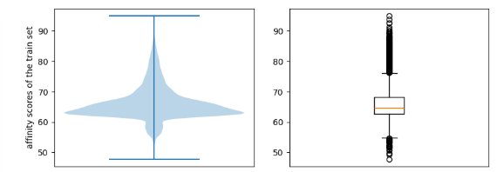

In Figure 2, a complete distribution of affinity scores is shown in boxplot form. The width of the middle of the figure shows that the distribution is continuous. The tails at both ends demonstrate that the dataset contains both weak and strong binders. This is significant because it verifies that the regression target behaves well. Additionally, most affinity scores are concentrated between 60 and 67, indicating that the majority of samples have moderate binding affinity.

The median, interquartile range, and outliers are highlighted in the box graphic in Figure 3. The presence of outliers suggests that the binding affinities of some ligand-protein pairings are unusually high or low. Model training is stabilized by the narrow IQR, which indicates that the majority of samples fall within a stable range.

Figure 4a Figure 4b Figure 5
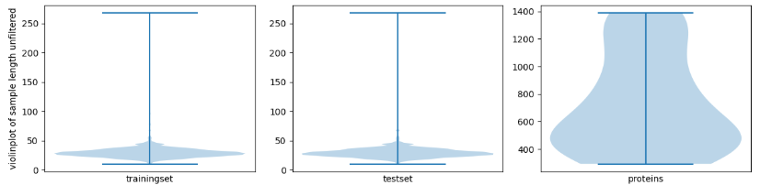c
Figure 4c Figure 4d
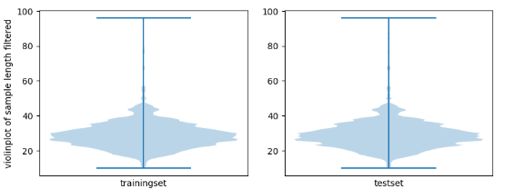
The median, interquartile range, and outliers are highlighted in the box graphic in Figure 3. The presence of outliers suggests that the binding affinities of some ligand-protein pairings are unusually high or low. Model training is stabilized by the narrow IQR, which indicates that the majority of samples fall within a stable range.

model choice and results
We deployed a limited grid search to test different combinations of representations to explore which give the best results. In our first grid search, we tested for 5, 25 and 146 pieces to split the proteins into, yielding the following results.
molecule representation | protein representation | MAE
combined | BLOSUM62 in 5 pieces | 2.76
combined | PAM250 in 5 pieces | 2.77
combined | physicochemical in 5 pieces | 2.79
combined | one-hot in 5 pieces | 2.79
figure 5a: The four best results of internal validation of our first grid search

These results show that dividing the proteins into 5 pieces works best out of the 3 amounts chosen. Furthermore, using the combined representation works better than using either of them separately. Based on these conclusions we deployed a second grid search, this time using 2, 3, 7 and 10 for the amounts of pieces to investigate, and on this occasion, only combined representations are used, yielding the following results:

molecule representation | protein representation | MAE
combined | physicochemical in 2 pieces | 2.69
combined | PAM250 in 3 pieces | 2.71
combined | BLOSUM62 in 3 pieces | 2.71
combined | one-hot in 2 pieces | 2.72
figure 5b: The four best results of internal validation of our second grid search

This shows that representing proteins in 2 pieces using their physicochemical properties is likely the best route to ensure a low mean absolute error. Consequently, we chose these representations for our final model for our submission to Kaggle, which subsequently partially confirms its quality with a public score of 2.48 and a private score of 2.43

Author contribution according to CRediT

Conceptualization | Write the initials here, e.g., “F.G. with contributions from A.B.C.”, “F.G. and A.B.C.”, or “all authors” when it is the case.  All authors
Methodology | All authors
Software | Derek with contributions from Sep
Validation | Derek
Formal analysis | Derek with contributions from Sep
Investigation | All authors
Data Curation | Derek with contributions from Sep
Writing - Original Draft | Nola
Writing - Review & Editing | Nola en Sep
Visualization | All authors

Usage of ChatGPT
Did you use ChatGPT or other language model assistants?
- Yes
□ No

! If you selected yes, make sure to submit the “LLM_usage_report” file alongside your submission.

References
This section does not count toward the page limit. Consider using automated tools to create references, such as Zotero.
- Mei, H., Liao, Z. H., Zhou, Y., & Li, S. Z. (2005). A new set of amino acid descriptors and its application in peptide QSARs. Biopolymers, 80(6), 775–786. https://doi.org/10.1002/bip.20296

Appendix

The protein representations in more detail:
For the physicochemical property encoding I have used two sources, I used physicochemical properties stored in peptidy and the 8 principal components from this source 1.
which are based on 50 physicochemical properties from 3 different categories. My implementation of this method has a few mistakes, as I did not filter out physicochemical properties based on correlation or that same property already being encoded in some of the principal components, this may have damaged model performance.
for substitution matrix embeddings I have used both PAM250 and BLOSUM62. These are seperate representations, I did not concatenate both because of how similar they are in what they represent, which induces a risk of overfitting. What I did was combine these representations with physicochemical property encoding. This results in six different representations to be tried: one-hot encoding, physicochemical property encoding, PAM250 encoding, BLOSUM62 encoding, PAM250 concatenated with physicochemical property encoding and BLOSUM62 concatenated with physicochemical property encoding.

